Life Cycle of a Star - Worksheet

# A STAR IS BORN – STAGES COMMON TO ALL STARS

All stars start as a **nebula. A nebula** is a large cloud of gas and dust. Gravity can pull some of the gas and dust in a nebula together. The contracting cloud is then called a **protostar.** A protostar is the earliest stage of a star’s life. **A star is born when the gas and dust from a** **nebula become so hot that nuclear fusion starts.** Once a star has “turned on” it is known as **a main sequence star**. When a main sequence star begins to run out of hydrogen fuel, the star becomes a **red giant** or a **red super giant.**

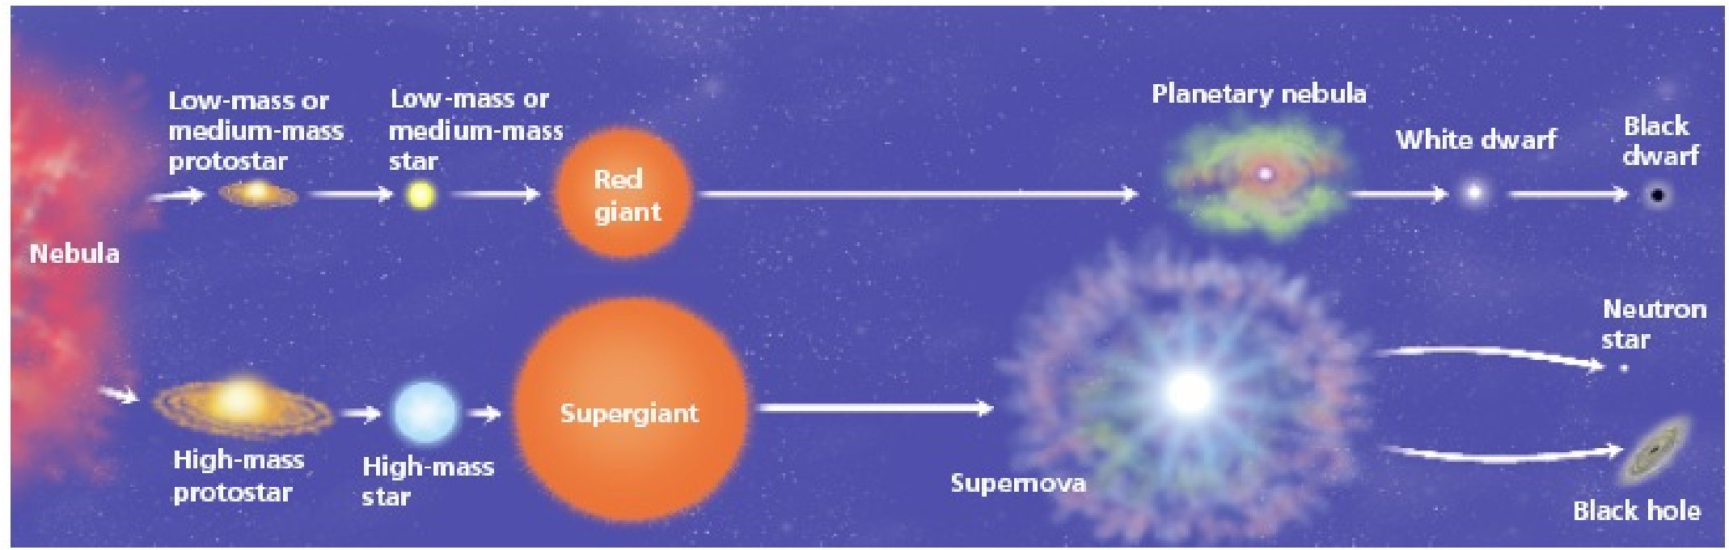

# THE DEATH OF A LOW OR MEDIUM MASS STAR

After a low or medium mass or star has become a red giant the outer parts grow bigger and drift into space, forming a cloud of gas called a **planetary nebula**. The blue-white hot core of the star that is left behind cools and becomes a **white dwarf.** The white dwarf eventually runs out of fuel and dies as a **black dwarf.**

# THE DEATH OF A HIGH MASS STAR

A dying red super giant star can suddenly explode. The explosion iscalled a **supernova.** After the star explodes, some of the materials from the star are left behind. This material may form a neutron star. **Neutron stars** are the remains of high-mass stars. The most massive stars become **black holes** when they die. After a large mass star explodes, a large amount of mass may remain. The gravity of the mass is so strong that gas is pulled inward, pulling more gas into a smaller and smaller space. Eventually, the gravity becomes so strong that nothing can escape, not even light.

## Question Sheet

Just like living things and humans, stars have a life cycle, which consists of birth, growth, development, middle age, old age, and death. The life cycle of a star spans over billions of years.

## Section One - Sequencing

The stages below are not in the right order. Number the stages in the correct order.

_____ The star begins to run out of fuel and expands into a **red giant** or **red super giant**.

_____ Stars start out as diffused clouds of gas and dust drifting through space. A single one of these clouds is called a **nebula**

_____ What happens next depends on the mass of the star.

_____ Heat and pressure build in the core of the **protostar** until **nuclear fusion** takes place.

_____ The force of gravity pulls a nebula together forming clumps called **protostars**.

_____ Hydrogen atoms are fused together generating an enormous amount of energy igniting the star causing it to shine.

## Section Two - Vocabulary

Match the word on the left with the definition on the right.

|  |  |  |
| --- | --- | --- |
| **____ black dwarf** |  | **e.** star left at the core of a planetary nebula |
| **____ white dwarf** |  | **g.** a red super giant star explodes |
| **____ nebula** |  | **c.** what a medium-mass star becomes at the end of its life |
| **____ protostar** |  | **b.** a large cloud of gas or dust in space |
| **____ supernova** |  | **a.** exerts such a strong gravitational pull that no light escapes |
| **____ neutron star** |  | **d.** the earliest stage of a star ’s life |
| **____ black hole** |  | **f.** the remains of a high mass star |

## Section Three – Understanding Main Ideas - Low Mass Star

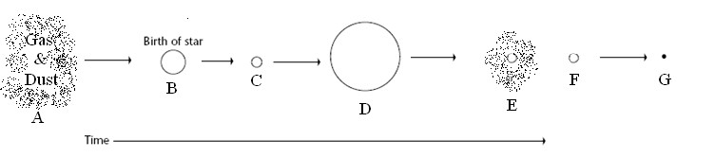

**____ 1.** Red giant

**____ 2.** Protostar

## ____ 3. Nebula

**____ 4.** Black dwarf

**____ 5.** The stage the sun is in

____ **6.** White dwarf

____ **7**. Planetary Nebula

## Section Four – Understanding Main Ideas - High Mass Star

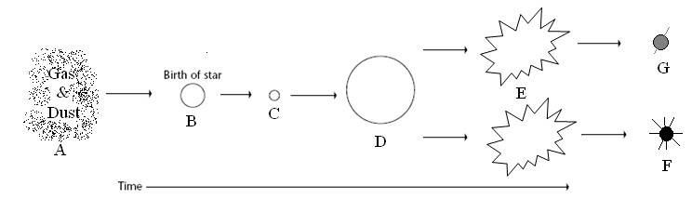

**____ 1.** Black Hole

____ **2**. Supernova

____ **3**. Protostar

____ **4**. Gravity causes this to condense into a protostar

____ **5**. Main sequence star

____ **6**. When a star begins to run out of fuel and grows larger

____ **7**. Neutron star

## Section Five – Graphic Organizer – Putting it all Together

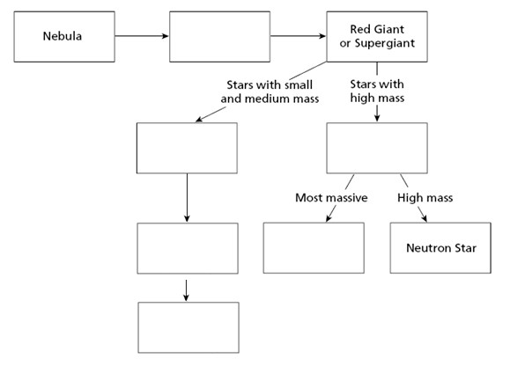

## Section Six – Venn Diagram - Compare and Contrast

